Project Name: OpenCart Demo
Module: Login, Product Search, Cart & Checkout
Testing Type: Manual Testing
Webpage URL: https://demo.opencart.com/

● Scenario ID: 1a
Scenario: Open OpenCart website
Test Steps:
Launch OpenCart Demo website
Screenshots:

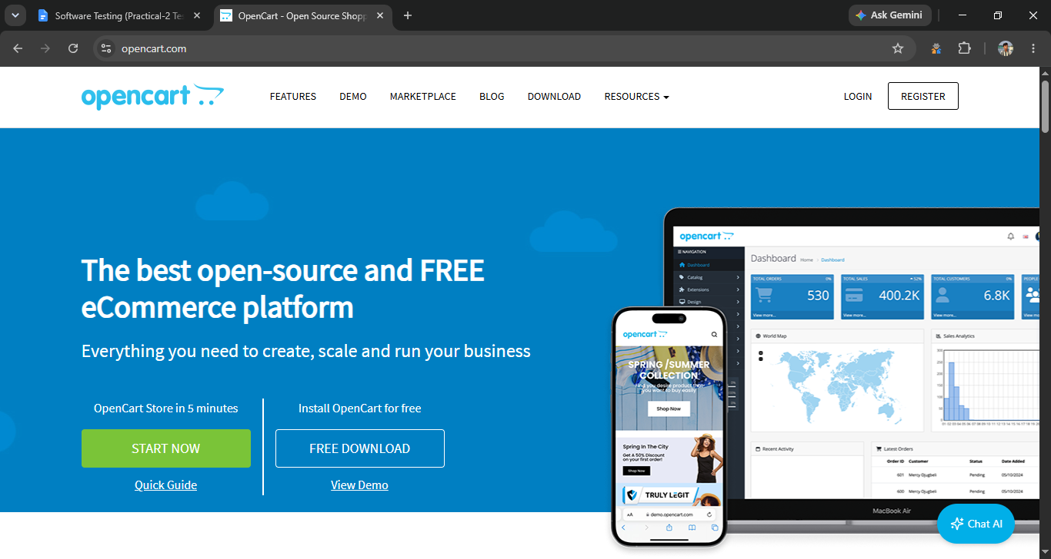
● Scenario ID: 1b
Scenario: Login with valid credential
Test Steps:
- Click Login
- Enter Email & Password
- Click Login
Screenshots:
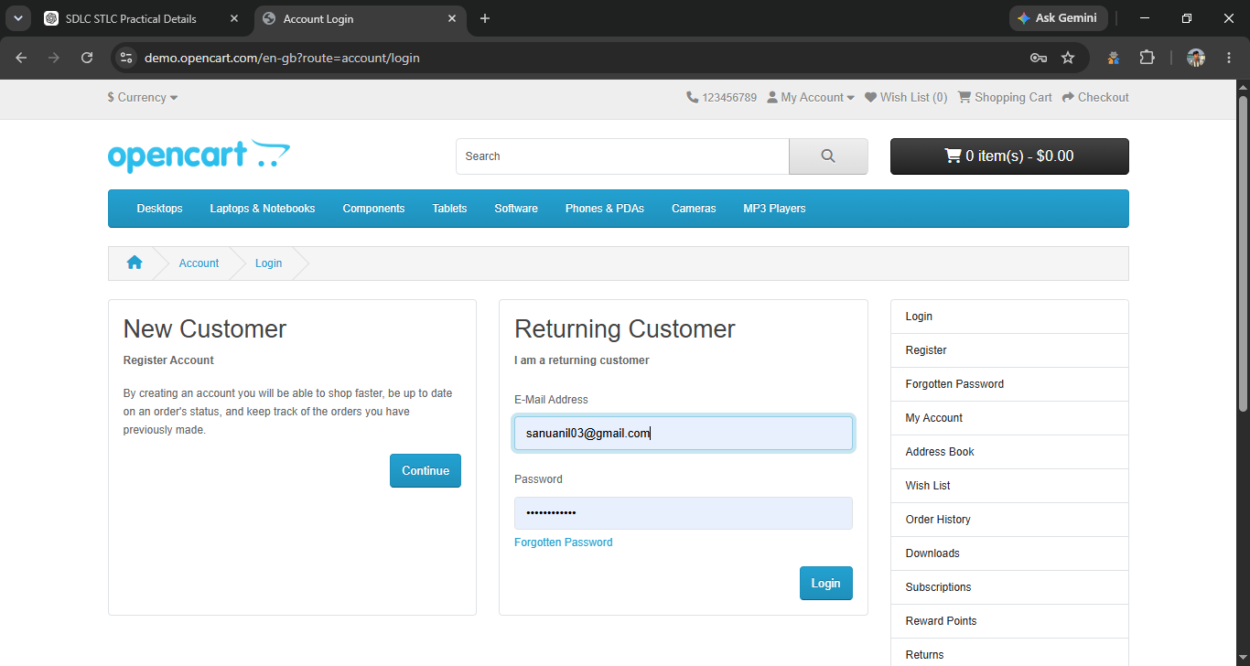
● Scenario ID: 1c
Scenario: Login with Invalid Password
Test Steps:
1. Enter valid email and
2. incorrect password
3. Click login
Screenshots:
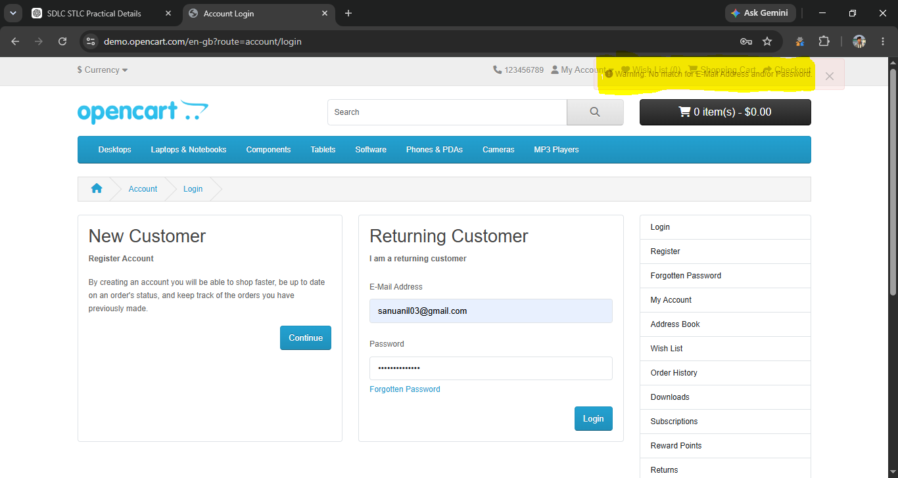

● Scenario ID: 2a
Scenario: Search product
Test Steps:
1. Search for a product

Screenshots: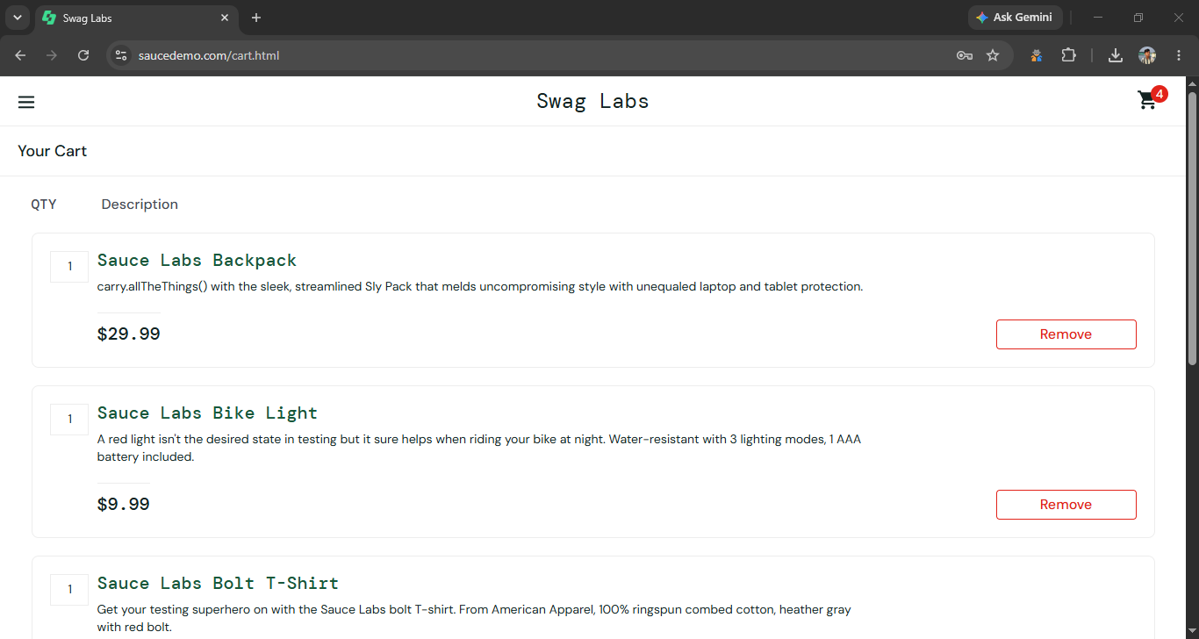

● Scenario ID: 2b
Scenario: Remove Product from Cart
Test Steps:
1. Click Remove

Screenshots:


● Scenario ID: 2b
Scenario: Proceed to Checkout
Test Steps:
1. Click Checkout

Screenshots:
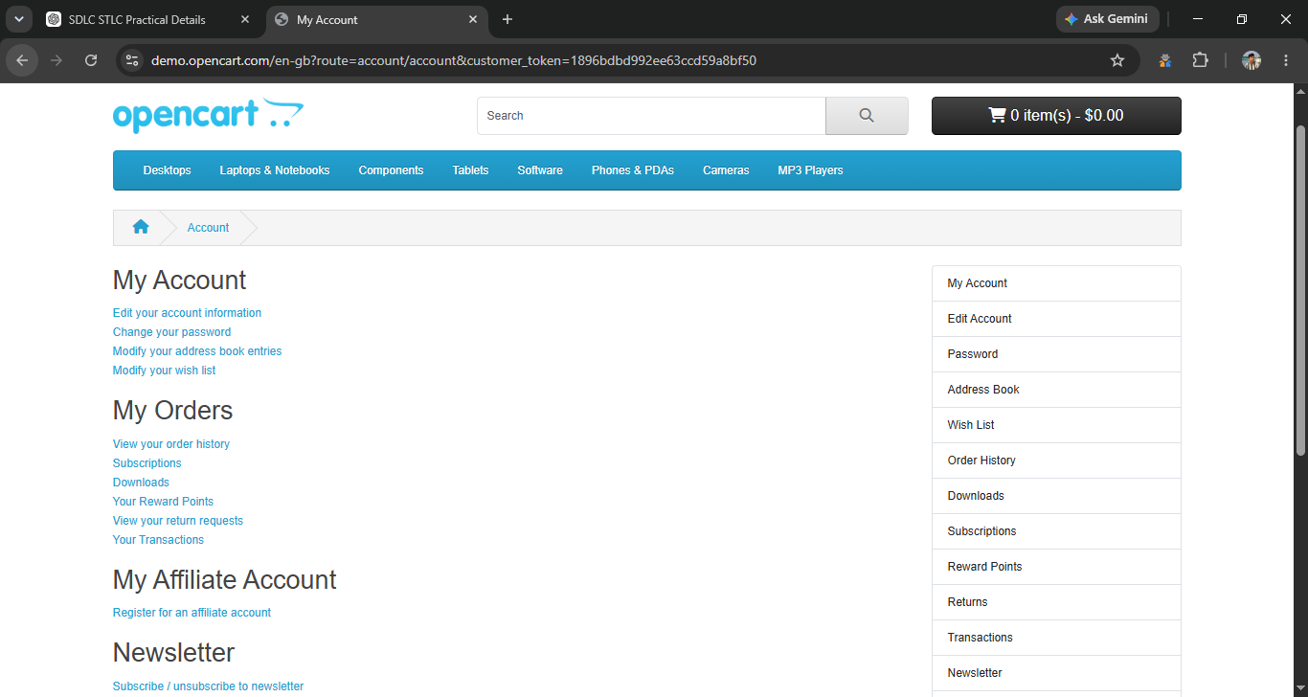

● Scenario ID: 2b
Scenario: Proceed to Checkout
Test Steps:
1. Click Checkout

Screenshots:


Summary of Test Results
- Total Test Cases: 15
- Passed: 14
- Failed: 1
- Pass %: 93.33%

● Conclusion and Recommendations
Pass Rate: 93.33% – Application Performs Well with Minor Improvements Required

● Issues Found

1. Product Not Displayed in Shopping Cart (3b)
After adding a product to the cart and opening the Shopping Cart page, the selected product was not displayed as expected.

2. Checkout Validation Issue (5b)
When mandatory billing details were left empty during checkout, the expected validation message was not displayed correctly.

● Recommendations

1. Improve Cart Synchronization
Ensure that products added to the cart are correctly synchronized and displayed on the Shopping Cart page.

2. Strengthen Checkout Validation
Validate all mandatory billing fields and display clear error messages before allowing the user to proceed with checkout.

